

Role Title: SO 1-2 Legal Officer

Departmentment

Level 2: Team Leader

Business Support: Legal

Legal Services



Job Family Level

Job Family

Professional Profile

Role Purposexxxxxxxxxxxxxxxxxxxxxxxxxxxx...............................................

To provide a high quality, efficient and effective legal service commensurate to the standard of a newly qualified lawyer to the clients of the Joint Legal Service which supports their organisational priorities and manages legal risk.   
  
Role Accountabilitiesxxxxxxxxxxxxxxxxxxxx……..xxxxxxxxxxxxxxxxxxxxxX

* To formulate and deliver in a variety of formats clear and accurate legal and procedural advice which is commensurate with the level of skills of a junior lawyer.
* To have conduct of a litigious and/or non-contentious caseload which in the opinion of the Head of Legal Services is appropriate to the grade of the post.
* To undertake and present legal research.
* To provide representation including advocacy in all courts, where rights of audience exist.
* To instruct Counsel and other external legal professionals as necessary and manage the quality and cost of the service provided.
* To assist the more senior colleagues in the department in the conduct of complex legal matters.
* To develop policy, practice and process which furthers best practice for legal services and its clients.
* As part of departmental and corporate commitment to learning and development, plan and deliver training to colleagues and clients.
* To attend multi-disciplinary and inter-agency meetings and professional working groups within Cheshire and beyond.
* To carry out such other duties which are consistent with the nature, responsibilities and grading of the post.
* The post holder will be required to work up to 8 Saturdays per annum for which the applicable standby allowance/overtime payment will be made.

For the post holders level of responsibility ensure that all; arrangements, activities, equipment, supervision and staff health, welfare and training are complied with as fully detailed in the Health and Safety Policy.

It is the responsibility of all staff to promote equality, diversity and Human Rights in working practices including developing and maintaining positive working relationships, ensuring that colleagues are treated fairly, contributing to developing equality of opportunity in working practices and challenging inappropriate conduct. Staff should treat everyone with fairness and impartiality, whilst recognising differences in needs, perspectives, backgrounds and cultures.   
  
Notwithstanding the details in this job description, the job holder may be required to undertake other duties up to a level consistent with the principal responsibilities of the job.

Experience, Qualifications & SkillsxxxxxxxxxxxxxxxxxxxxxxxxxXXX……xxx

**Prior Education and Experience**

* Educated to Level 5 relevant to the post, namely a practicing solicitor, barrister, legal executive or equivalent relevant experience.
* Significant experience of working in a legal office.
* Significant experience of legal research techniques.
* Some experience of having sole or primary conduct of a legal caseload.
* Some experience of formulating and providing legal advice without direct supervision.
* Some advocacy experience in a judicial, quasi-judicial or tribunal setting.

**Skills**

Essential

* Significant ability to compose letters, statements, reports and notes of legal advice.
* Significant competency in using computer systems including Microsoft packages
* Significant skills which demonstrate ability to operate effectively as part of a team in a legal practice
* Some knowledge of emergency service related legislation
* Some knowledge of health and safety, employment, procurement and equalities legal framework

Continuous Professional Development & Mandatory Training Requirements

|  |  |  |
| --- | --- | --- |
| Mandatory  Training |  |  |

|  |  |  |
| --- | --- | --- |
| Department Capability Training Requirement.  A proportion of Officers will complete and maintain the below skills to ensure functionality of the department or unit. |  |  |

All roles are expected to know, understand and act within the ethic & values of the Police Service.

Behaviours – Competency and Values Framework for Policing (CVF)xxxxxxx

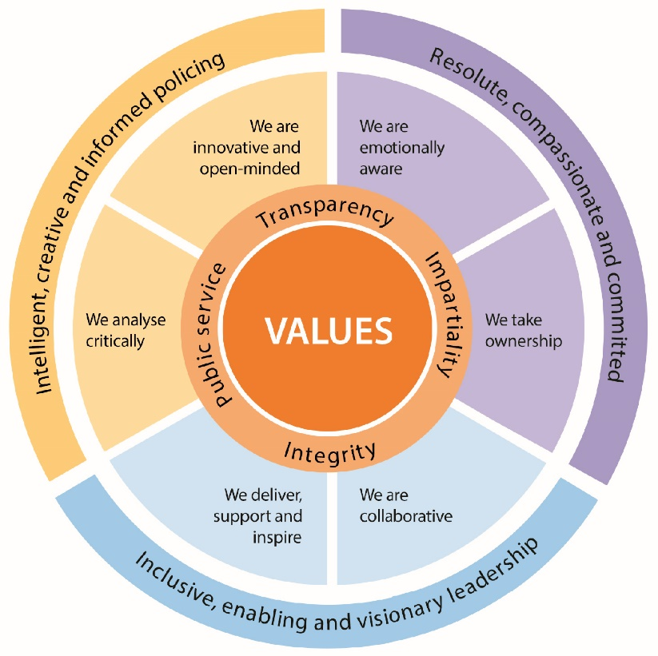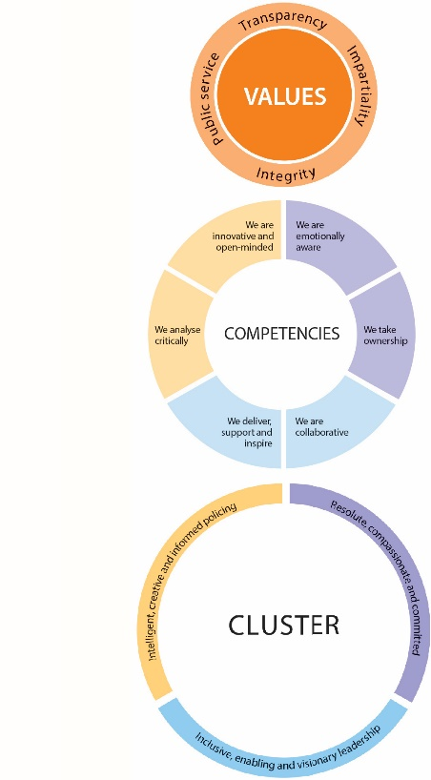

CVF Information XX

**This role is expected to operate at the below level for each competency.**

See the attached for full details of the behaviour expected.

Competency

Cluster



Level

Resolute, Compassionate & Committed

**2**

**2**

We are emotionally aware

We take ownership

Inclusive, enabling & visionary leadership

We are collaborative

We deliver, support and inspire

**2**

**2**

We analyse critically

We are innovative and open-minded

**2**

**2**

Intelligent, creative and informed policing

Additional Role Requirements xxxxXXXxxxxxxxxXXXXXXXXXXXXXXXXxxxxx

Enhanced

N/A

N/A

N/A

N/A

Laptop, Smartphone

N/A

N/A

Vetting Level

Warranted/Designated Power

Allowances

Tenure Period

Politically Restricted Role (Police Staff Only)

IT Equipment / Software Required

Apprenticeship Standard

Repeated exposure to content of a vulnerable or sensitive nature requiring an annual welfare check