

Role Title: SO1-2 Quality Manager

Departmentment

Level 2: Team Leader

Major Crime: Forensics

Forensics

Forensic Investigations



Job Family Level

Job Family

Professional Profile

Role Purposexxxxxxxxxxxxxxxxxxxxxxxxxxxx...............................................

To manage, maintain, develop and implement the Quality Management system within Forensic Investigations and the broader Force, to ensure high quality standards of forensic service provision and to comply with EU legislation and the Forensic Regulator’s requirements for Forensic Service Providers. To advise the Forensic Investigations Senior Management Team on quality requirements; and managing performance and continuous improvement within the department.  
  
  
Role Accountabilitiesxxxxxxxxxxxxxxxxxxxx……..xxxxxxxxxxxxxxxxxxxxxX

* Support the Head of Forensic Investigations by maintaining, managing and developing the Quality Management System to ensure high quality standards of Forensic Service Provision and ensure compliance to ISO 17025, ISO 17020, ILAC G19 and FSR Codes
* Working knowledge of the functions within the Organisation and Knowledge of all Forensic Investigations policies, practices and procedures including management and technical requirements to enable them to ensure compliance with the Quality Standards and adherence to the Quality Management System.
* Line manage the Quality Management Team.
* Advise the Head of Forensics on and deliver new policies, practices and standard operating procedures ensuring compliance with, the Forensic Regulators Codes of Practice and other relevant guidance.
* Undertake audits and inspections of Forensic Investigations for both Cheshire Constabulary and other Forces in line with the requirements of the Force’s Quality Standards. Review Auditor’s work to ensure they are of the right quality and direct remedial action where required.
* Provide the Head of Forensic Investigations with up-to-date information on the registration and progress of Staff and Customer Feedback, Corrective, Preventive and Improvement actions. Negotiate and influence Unit

Managers to ensure compliance.

* Allocate work to the respective Unit Manager in line with the requirements of the Standard and negotiate and influence them in order to ensure compliance.
* Maintain and update records in relation to the Quality Management System to ensure it contains the most up to date, relevant versions of processes and procedures to ensure compliance with the Quality Standard.
* To be the System Administrator of the QMS, developing or creating new workflows when required and updating organisational charts and users in line with business changes.
* Represent the Force at local, regional and national meetings. Support the Head of Forensic Investigations
* Promote a culture of continuous improvement

This post is subject to an enhanced level of vetting which must be satisfied before appointment

In order to practice within the field of forensics, it is imperative that all staff work in compliance with ISO standards and relevant legislation in order to extend and maintain the forces accreditation schedule in accordance with the Forensic Science Regulator. Such work involves, but is not limited to, engagement with the QMS, maintenance of training and competence, involvement with proficiency tests, technical management, validation work, auditing, non-conformance investigations, completion of corrective and preventative tasks, updating the relevant documentation and involvement in UKAS assessment visits.

For the post holders level of responsibility ensure that all; arrangements, activities, equipment, supervision and staff health, welfare and training are complied with as fully detailed in the Health and Safety Policy.   
  
It is the responsibility of all staff to promote equality, diversity and Human Rights in working practices including developing and maintaining positive working relationships, ensuring that colleagues are treated fairly, contributing to developing equality of opportunity in working practices and challenging inappropriate conduct. Staff should treat everyone with fairness and impartiality, whilst recognising differences in needs, perspectives, backgrounds and cultures.   
  
Notwithstanding the details in this job description, the job holder may be required to undertake other duties up to a level consistent with the principal responsibilities of the job.

Experience, Qualifications & SkillsxxxxxxxxxxxxxxxxxxxxxxxxxXXX……xxx

**Prior Education and Experience**

* Educated to Level 6 – Degree Equivalent in a Science subject
* Must possess or be willing to gain within 6 months of employment:
* ISO Auditor Certificate
* ISO Quality Management Certificate.
* Significant Experience working with International Standards (ISO), preferably ISO/IEC 17025:2017/ ISO 17020;2012 or quality control/assurance systems.
* Experience working in a forensic environment is desirable.
* Significant supervisory experience

**Skills**

Essential

* Knowledge of quality management systems desirable
* Openness to change
* Organisational skills
* Negotiating and influencing

Continuous Professional Development & Mandatory Training Requirements

|  |  |  |
| --- | --- | --- |
| Mandatory  Training |  |  |

|  |  |  |
| --- | --- | --- |
| Department Capability Training Requirement.  A proportion of Officers will complete and maintain the below skills to ensure functionality of the department or unit. |  |  |

All roles are expected to know, understand and act within the ethic & values of the Police Service.

Behaviours – Competency and Values Framework for Policing (CVF)xxxxxxx

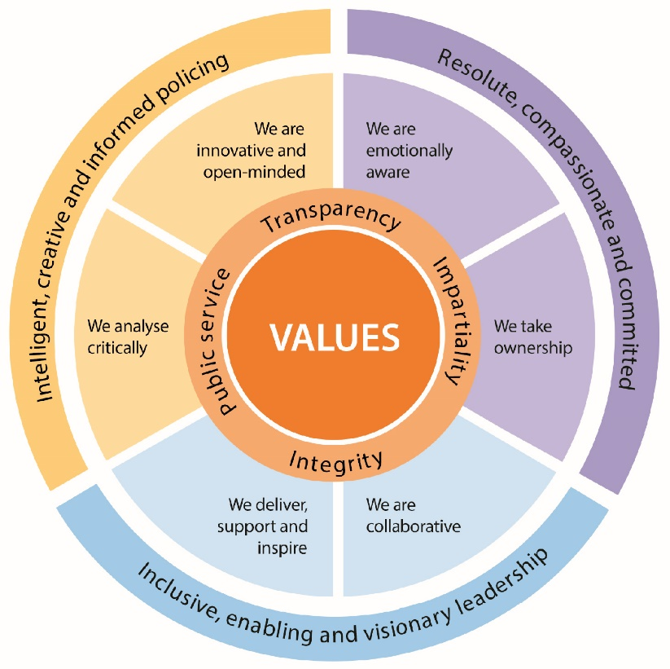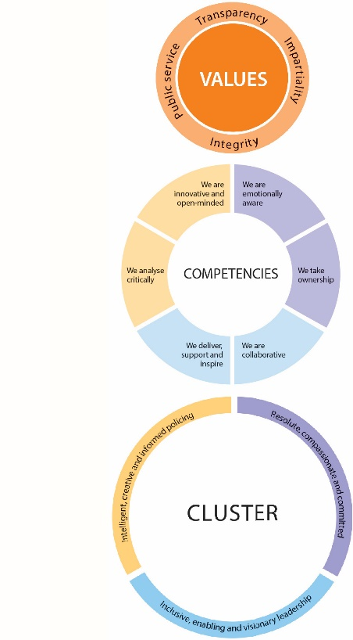

CVF Information XX

**This role is expected to operate at the below level for each competency.**

See the attached for full details of the behaviour expected.

Competency

Cluster



Level

Resolute, Compassionate & Committed

**2**

**2**

We are emotionally aware

We take ownership

Inclusive, enabling & visionary leadership

We are collaborative

We deliver, support and inspire

**2**

**2**

We analyse critically

We are innovative and open-minded

**2**

**2**

Intelligent, creative and informed policing

Additional Role Requirements xxxxXXXxxxxxxxxXXXXXXXXXXXXXXXXxxxxx

Enhanced

N/A

N/A

N/A

N/A

Laptop, Smartphone

N/A

N/A

Vetting Level

Warranted/Designated Power

Allowances

Tenure Period

Politically Restricted Role (Police Staff Only)

IT Equipment / Software Required

Apprenticeship Standard

Repeated exposure to content of a vulnerable or sensitive nature requiring an annual welfare check