

Role Title: Inspector – Force Incident Manager

Departmentment

i.e. College of Policing Role profile – specialist or core rank

xxxxxx

Response and Resolution

Force Control Centre



Job Family Level

Function

Professional Profile

Role Purposexxxxxxxxxxxxxxxxxxxxxxxxxxxx...............................................

Inspectors manage teams of sergeants, constables and police staff and/or portfolios. Post holders may be the senior operational officer or manage assigned specialist policing functions. This role carries specific legal powers to enable the maintenance of law and order.

Inspectors plan, manage and monitor operational policing activity. They effectively and efficiently direct the deployment of resources to incidents, including critical incidents. Inspectors manage and mitigate risk effectively in order ensure the safety and wellbeing of officers, staff and the public and to respond effectively to problems, incidents and crime.

In addition to the core responsibilities of an Inspector, the role holder will be responsible for the initial assessment, strategic intervention and management of spontaneous incidents, providing a 24/7 single point of contact for the Force in regards to risk and threat management, thereby safeguarding the reputation and integrity of the Cheshire Constabulary.

Role Accountabilitiesxxxxxxxxxxxxxxxxxxxx……..xxxxxxxxxxxxxxxxxxxxxX

* Plan, manage and monitor the front line and/or specialist operational policing activity for their team, managing competing demands and priorities to make informed deployment decisions and ensure best use of available resources.
* Lead, motivate and engage a team of sergeants, constables and police staff, protecting and promoting workforce wellbeing to uphold professional standards and enable a high performing team.
* Contribute to the setting, monitoring and assessment of team/individual key performance indicators in alignment with wider objectives, taking corrective action as necessary to ensure that the team effectively contribute towards the achievement of Force goals.
* Manage the initial response to critical incidents, in alignment with relevant frameworks and guidance, ensuring appropriate resource allocation and risk management to enable effective service delivery.
* Manage matrix teams providing clear tasking in accordance with operational policing plans and priorities to provide an efficient and effective response to problems, incidents and crime.
* Review and report on team expenditure to ensure the efficient use of available budgets and maximise value for money.
* Analyse performance data and information against team objectives in order to effectively inform workforce planning, budgets and the measurement of department and force goals.
* Identify, manage and mitigate operational threats and risks in line with national guidance and operational policing plans in order to ensure the safety of officers, staff, and the public.
* Develop and maintain relationships with colleagues, communities and partners to drive collaboration across policing and wider public services provision.
* Analyse and evaluate the effectiveness of existing processes and practices within area of work in order to identify and implement opportunities for change and innovation, promote best practice and enable improvement, problem solving approaches and evidence based policing within teams.

Role Specific Accountabilities

In addition to core responsibilities.

* To maintain a live time strategic perspective on force wide policing demands and response to incidents, ensuring regular liaison with area supervision and senior managers, and escalation of deployments as appropriate.
* To risk assess incidents which may require the spontaneous deployment of Authorised Firearms Officers in line with the NDM / Manual Guidance on the Management , Command and Deployment of Armed Officers, and to manage the Initial Phase of such deployments, acting as Initial Tactical Firearms Commander
* To identify and initiate appropriate and timely action in response to Major, Major Incident Standby or Critical Incidents, acting as Silver Commander to ensure that public safety, public reassurance issues are addressed and the Force reputation maintained.
* To identify, assess and initiate incidents involving high risk “Crime in Action”, calling upon the appropriate specialist resources to manage their investigation.
* To identify, assess and monitor incidents which contain significant risk to vulnerable parties, and to monitor the response and intervene, where necessary, to ensure that they are progressed.
* To lead a team of staff to ensure that call handling performance, and appropriate resource deployment, is maximised with particular regard to the safeguarding of vulnerable persons and quality service delivery.
* Must be able to travel anywhere in the Force area
* Subject to an enhanced form of vetting
* This post is subject to a 2 year minimum tenure

For the post holders level of responsibility ensure that all; arrangements, activities, equipment, supervision and staff health, welfare and training are complied with as fully detailed in the Health and Safety Policy. It is the responsibility of all staff to promote equality, diversity and Human Rights in working practices including developing and maintaining positive working relationships, ensuring that colleagues are treated fairly, contributing to developing equality of opportunity in working practices and challenging inappropriate conduct.  Staff should treat everyone with fairness and impartiality, whilst recognising differences in needs, perspectives, backgrounds and cultures.

Not withstanding the details in this job description, the job holder may be required to undertake other duties up to a level consistent with the principal responsibilities of the job.

Experience, Qualifications & SkillsxxxxxxxxxxxxxxxxxxxxxxxxxXXX……xxx

**Prior Education and Experience**

Typically, an Inspector will have:

* Operational experience at Sergeant Level.
* Met all necessary local and national promotion requirements (or Direct Entry selection criteria) as defined in the National Police Promotions Framework (NPPF) or previous OSPRE process.

**Skills**

* Able to plan to short and medium-term cycles, to coordinate a range of activities appropriately within the function, to match these to available resources, and to identify and mitigate known risks to delivery.
* Able to develop and motivate a team and create strong engagement of individuals with their personal and team objectives and with Force values, behaviours and strategic priorities.
* Able to develop and implement an effective stakeholder and partner relationship plan which develops trusts and enables contributions.
* Able to engage a variety of audiences through a range of media to inform and/or persuade.
* Skilled in setting, monitoring and enabling high performance against team and individual performance objectives.
* Able to identify potential applications of new or improved practices related to area of work to improve ways of working.
* Able to contribute to resource planning, to manage financial budgets and utilise commercial acumen to make risk-based decisions that deliver effective outcomes within the resources allocated.
* Able to seek out and identify a range of information to identify patterns, trends and options, and use SARA (scan, analyse, respond and assess) principles to solve multifaceted and complex problems.
* Skilled in coaching and mentoring to enable appropriate career and professional development.
* Able to manage the delivery of change initiatives within own team.
* Able to problem solve and critically question and identify potential opportunities to enhance efficiency and/or effectiveness across teams.
* Able to maintain personal resilience and wellbeing in complex and challenging situations and enable others to develop their own personal resilience and wellbeing.

Continuous Professional Development & Mandatory Training Requirements

|  |  |  |
| --- | --- | --- |
| Mandatory  Training |  |  |

|  |  |  |
| --- | --- | --- |
| Department Capability Training Requirement.  A proportion of Officers will complete and maintain the below skills to ensure functionality of the department or unit. |  |  |

All roles are expected to know, understand and act within the ethic & values of the Police Service.

Behaviours – Competency and Values Framework for Policing (CVF)xxxxxxx

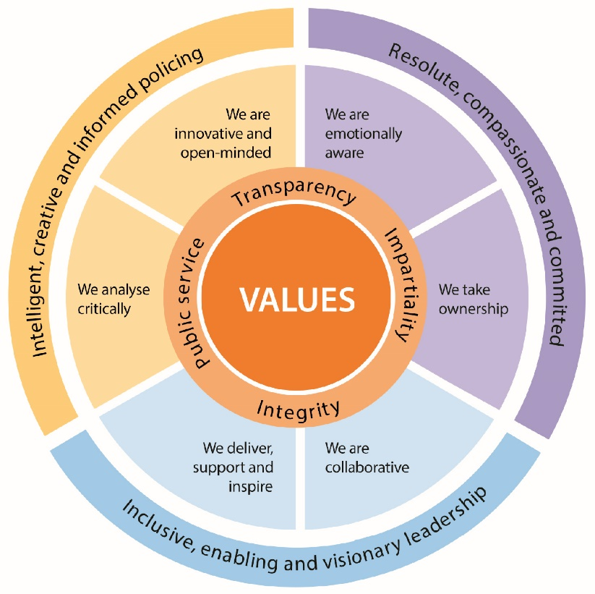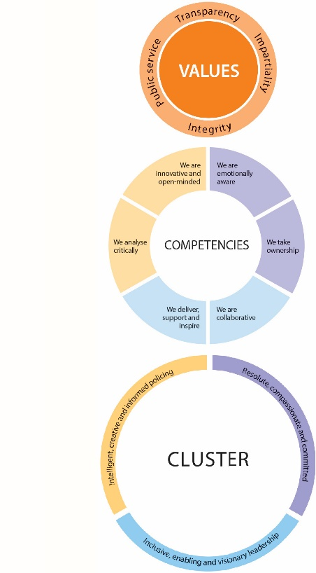

CVF Information XX

**This role is expected to operate at the below level for each competency.**

See the attached for full details of the behaviour expected.

Competency

Cluster



Level

Resolute, Compassionate & Committed

**2**

**2**

We are emotionally aware

We take ownership

Inclusive, enabling & visionary leadership

We are collaborative

We deliver, support and inspire

**2**

**2**

We analyse critically

We are innovative and open-minded

**2**

**2**

Intelligent, creative and informed policing

Additional Role Requirements xxxxXXXxxxxxxxxXXXXXXXXXXXXXXXXxxxxx

Recruitment

Warranted Powers

N/A

N/A

N/A

Tablet

N/A

N/A

Vetting Level

Warranted/Designated Power

Allowances

Tenure Period

Politically Restricted Role (Police Staff Only)

IT Equipment / Software Required

Apprenticeship Standard

Repeated exposure to content of a vulnerable or sensitive nature requiring an annual welfare check