

Role Title: S6 Technical and Digital Investigation Manager Support

Departmentment

Level 1: Service Deliverer

Major Crime: DMIU

Serious Organised Crime



Job Family Level

Job Family

Professional Profile

Role Purposexxxxxxxxxxxxxxxxxxxxxxxxxxxx...............................................

To provide specialist support for the DFU Technical manager to manage and maintain the Quality Management system within Digital Forensic Investigations to ensure high quality standards of forensic service provision and to comply with EU legislation and the Forensic Regulator’s codes of conduct, and also provide resilience support to the digital forensic examiner cadre.  
  
Role Accountabilitiesxxxxxxxxxxxxxxxxxxxx……..xxxxxxxxxxxxxxxxxxxxxX

* Direct and advise managers in all digital forensic applications to achieve and maintain accreditation against ISO 17025, ISO 17020 & FSR standards.
* Liaise with external auditors verbally and in writing on behalf of the Digital Forensic unit, and interpret their findings into plain language as specific actions for colleagues.
* Provide reports to the DFU Technical Manager demonstrating compliance with the Quality Management System, highlighting areas of non-compliance and recommendations for improvement.
* Using their knowledge of the appropriate Quality Management Standards, identify and evaluate the risk to the Quality Management System posed by operational changes within the Digital Forensic Unit and recommend courses of action to ensure compliance.
* Support the Digital Forensic Unit with investigations, conduct examinations of computers, digital devices, digital media and networks to obtain evidential material to support criminal investigations.
* The role will include examination / forensic acquisition and triage of mobile phonesy other similar digital devices.
* Research, Develop and Maintain a level of CPD in new legislation, updates of software / hardware and investigative tools along with digital trends to improve the quality of the evidence produced and improvements to procedures relevant to the role
* Ensure that all casework carried out complies with the Digital Forensic Quality management system.
* Provide evidence in Court to present any relevant evidential findings during your role in the investigation.
* As required - Attend warrants and conduct searches to support investigation that require eForensics support, Identify devices likely to hold electronic evidence and adhere to the ACPO guidelines for the examination of electronic evidence.
* Consult and work cooperatively with officers and staff of various ranks and from various agencies in order to ensure compliance with policy and procedures.
* You will be required to Mentor, develop, assist and assess new members of staff to the department.
* Must be prepared to handle materials that may be offensive and distressing.
* Maybe be required to work outside of office hours at weekends or bank holidays
* Confidentiality and trust must be maintained at all times.
* The post holder must be able to travel anywhere in the Force area
* Level of responsibility to ensure that all arrangements, activities, equipment, welfare and training are complied with as fully detailed in the Health and Safety Policy. This will include maintain all force issues equipment to a good standard and report any faults in line with ISO 17025.

In order to practice within the field of forensics, it is imperative that all staff work in compliance with ISO standards and relevant legislation in order to extend and maintain the forces accreditation schedule in accordance with the Forensic Science Regulator. Such work involves, but is not limited to, engagement with the QMS, maintenance of training and competence, involvement with proficiency tests, technical management, validation work, auditing, non-conformance investigations, completion of corrective and preventative tasks, updating the relevant documentation and involvement in UKAS assessment visits.

For the post holders level of responsibility ensure that all; arrangements, activities, equipment, supervision and staff health, welfare and training are complied with as fully detailed in the Health and Safety Policy.   
  
It is the responsibility of all staff to promote equality, diversity and Human Rights in working practices including developing and maintaining positive working relationships, ensuring that colleagues are treated fairly, contributing to developing equality of opportunity in working practices and challenging inappropriate conduct. Staff should treat everyone with fairness and impartiality, whilst recognising differences in needs, perspectives, backgrounds and cultures.   
  
Notwithstanding the details in this job description, the job holder may be required to undertake other duties up to a level consistent with the principal responsibilities of the job.

Experience, Qualifications & SkillsxxxxxxxxxxxxxxxxxxxxxxxxxXXX……xxx

**Prior Education and Experience**

Essential

* Educated to Level 6 in Forensic Computing, Computer Science or equivalent relevant experience
* Some experience working with ISO 17025, and /or ISO 17020 and the forensic regulators codes of practice is essential.
* Some experience of digital devices and knowledge of how data is stored

Desirable

* Accredited EN Certified Examiner (ENCE) is not essential but would be desirable for any further progression.

**Skills**

Essential

* Knowledge of the ISO standards, Forensic Regulator’s codes of practice and ILAC guidelines.
* Be able to identify the working components of digital devices and awareness of their functionality and understanding of digital evidence.
* Understand the use of the current technological advances and digital forensics in relation to assisting in the investigation of criminal offence.
* High level ability to take a flexible approach to tasks and work on own initiative
* High level to manage diverse activities at the same time
* High level ability to problem solve and work independently

Continuous Professional Development & Mandatory Training Requirements

|  |  |  |
| --- | --- | --- |
| Mandatory  Training |  |  |

|  |  |  |
| --- | --- | --- |
| Department Capability Training Requirement.  A proportion of Officers will complete and maintain the below skills to ensure functionality of the department or unit. |  |  |

All roles are expected to know, understand and act within the ethic & values of the Police Service.

Behaviours – Competency and Values Framework for Policing (CVF)xxxxxxx

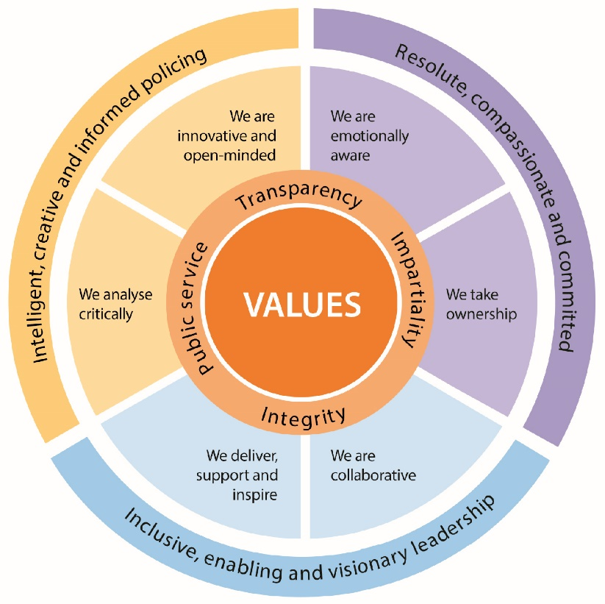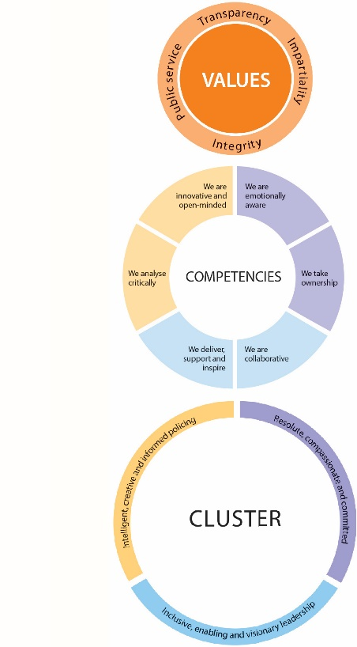

CVF Information XX

**This role is expected to operate at the below level for each competency.**

See the attached for full details of the behaviour expected.

Competency

Cluster



Level

Resolute, Compassionate & Committed

**2**

**2**

We are emotionally aware

We take ownership

Inclusive, enabling & visionary leadership

We are collaborative

We deliver, support and inspire

**2**

**2**

We analyse critically

We are innovative and open-minded

**2**

**2**

Intelligent, creative and informed policing

Additional Role Requirements xxxxXXXxxxxxxxxXXXXXXXXXXXXXXXXxxxxx

Enhanced

Designated Powers

N/A

N/A

N/A

Desktop

N/A

N/A

Vetting Level

Warranted/Designated Power

Allowances

Tenure Period

Politically Restricted Role (Police Staff Only)

IT Equipment / Software Required

Apprenticeship Standard

Repeated exposure to content of a vulnerable or sensitive nature requiring an annual welfare check