

Role Title: S2 MFSS HR Service Administrator

Departmentment

i.e. College of Policing Role profile – specialist or core rank

Level 1: Service Deliverer

Multi Force Shared Service

Multi Force Shared Service



Job Family Level

Job Family

Professional Profile

Role Purposexxxxxxxxxxxxxxxxxxxxxxxxxxxx...............................................

Working within the Multi Force Shared Service Centre this role will be responsible for delivering a professional administration service, receiving and actioning a wide range of human resources  and training specific information and correspondence.

Utilise a Human Resources technology based solution to deliver a high level of customer service in accordance with agreed standards and targets.

Role Accountabilitiesxxxxxxxxxxxxxxxxxxxx……..xxxxxxxxxxxxxxxxxxxxxX

* Receive, review, and process documents, verifying completion, accuracy, and compliance with established policy and procedural requirements – e.g. medical reports, return to work interviews, application forms, training requests, course bookings, and information requests from third parties.
* Create, update and close tasks from the service management system to fulfil customer’s requirements together with updating and advising customers as necessary of the actions undertaken on their behalf.
* Answer telephone queries from customers with regards to general HR/training service issues that the customer was unable to deal with for them selves via self service.
* Manage and action tasks and workflows in line with Service Level Agreements.
* Follow up with customers as necessary to ensure resolution of problems involving incomplete, inaccurate, or non-compliant documentation
* Accurately enter data/documentation into the appropriate HR system to generate records and notify external providers.
* Maintain and update the HR system with actions taken and ensure proper recording and filing/disposal of all documents received by the MFSS Centre, in accordance with established policies and procedural guidelines
* As part of the HR Administration pool demonstrate flexibility by providing backup and assistance to any of the other  MFSS HR teams as demands dictates.

For the post holders level of responsibility ensure that all; arrangements, activities, equipment, supervision and staff health, welfare and training are complied with as fully detailed in the Health and Safety Policy

It is the responsibility of all staff to promote equality, diversity and Human Rights in working practices including developing and maintaining positive working relationships, ensuring that colleagues are treated fairly, contributing to developing equality of opportunity in working practices and challenging inappropriate conduct.  Staff should treat everyone with fairness and impartiality, whilst recognising differences in needs, perspectives, backgrounds and cultures.

Notwithstanding the details in this job description, the job holder may be required to undertake other duties up to a level consistent with the principal responsibilities of the job.

Experience, Qualifications & SkillsxxxxxxxxxxxxxxxxxxxxxxxxxXXX……xxx

**Prior Education and Experience**

* Qualified to Level 2 of the National Qualifications Framework
* Some experience of working in a customer focussed business administration role which will include:
* Working to targets whilst achieving a high degree of accuracy and quality in dealing with information
* Working to defined Key Performance Indicators
* Processing of sensitive and confidential information
* Dealing with HR related customer queries over the phone

**Skills**

* Excellent communication and customer service skills both in written form and over the phone
* Computer literacy and working knowledge of Microsoft Office
* Attention to detail and ability to record information accurately
* Flexible approach to working within different teams as required
* Understanding of the importance of dealing with employee related information in a sensitive and confidential manner.

Continuous Professional Development & Mandatory Training Requirements

|  |  |  |
| --- | --- | --- |
| Mandatory  Training |  |  |

|  |  |  |
| --- | --- | --- |
| Department Capability Training Requirement.  A proportion of Officers will complete and maintain the below skills to ensure functionality of the department or unit. |  |  |

All roles are expected to know, understand and act within the ethic & values of the Police Service.

Behaviours – Competency and Values Framework for Policing (CVF)xxxxxxx

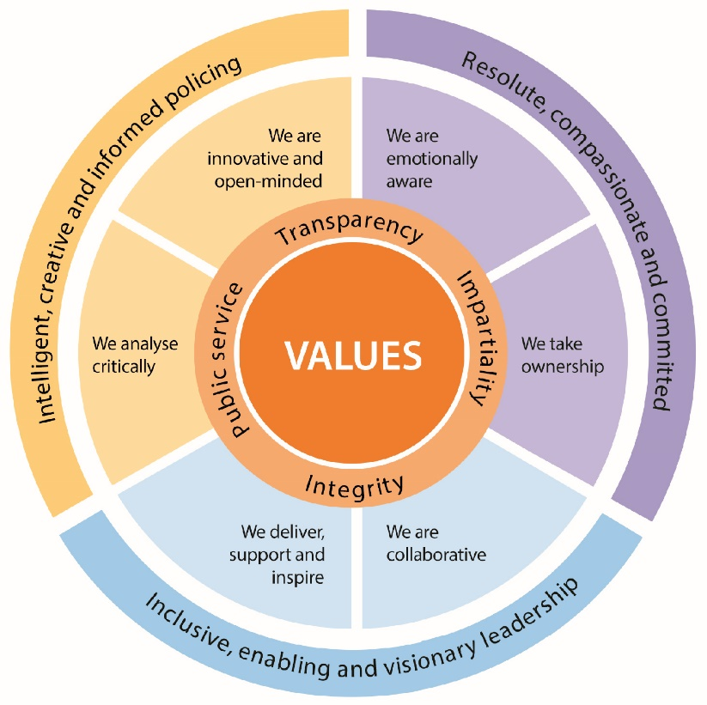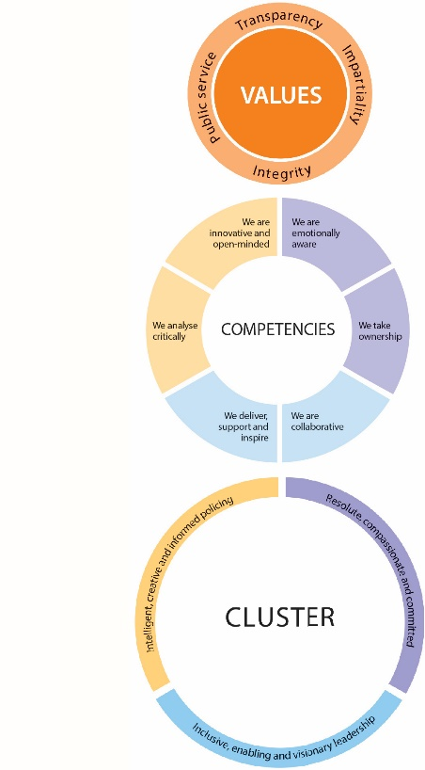

CVF Information XX

**This role is expected to operate at the below level for each competency.**

See the attached for full details of the behaviour expected.

Competency

Cluster



Level

Resolute, Compassionate & Committed

**1**

**1**

We are emotionally aware

We take ownership

Inclusive, enabling & visionary leadership

We are collaborative

We deliver, support and inspire

**1**

**1**

We analyse critically

We are innovative and open-minded

**1**

**1**

Intelligent, creative and informed policing

Additional Role Requirements xxxxXXXxxxxxxxxXXXXXXXXXXXXXXXXxxxxx

Recruitment

N/A

N/A

N/A

N/A

Desktop

Level 3 HR Support

N/A

Vetting Level

Warranted/Designated Power

Allowances

Tenure Period

Politically Restricted Role (Police Staff Only)

IT Equipment / Software Required

Professional Registration / Licences

Repeated exposure to content of a vulnerable or sensitive nature requiring an annual welfare check